## Montane Hardwood (MHW)

### General Information

### Cover Type Overview

* 17,024 acres / 6889 hectares
* Crosswalks
  + EVeg: Regional Dominance Type 1
    - Interior Mixed Hardwood
    - California Bay
    - Canyon Live Oak
    - Madrone
    - Bigleaf Maple
    - Interior Live Oak
    - Montane Mixed Hardwood
  + LandFire BpS Model: 0610430 Mediterranean California Mixed Evergreen Forest (shared with Douglas Fir – Tanoak)
  + Presettlement Fire Regime Type: Mixed Evergreen
* Ultramafic
  + This type is created by intersecting an ultramafic soils/geology layer with the existing vegetation layer. Where cells intersect with MHW they are assigned to the ultramafic modifier.

### Vegetation Description

The MHW landcover type is highly variable and diverse (Allen-Diaz et al. 2007). Typically, the vegetation is composed of a pronounced hardwood tree layer, with an infrequent and poorly developed shrub stratum, and a sparse herbaceous layer (McDonald 1988). The dominant oak species vary by topography, soil, and elevation. Montane hardwood forests typically lack *Quercus douglasii* and *Quercus lobata* (although mixed oak-*Quercus wislizeni*-*Pinus sabiniana* in the Sierra Nevada includes these species). Characteristic oaks include *Quercus chrysolepis*, *Q. wislizeni*, *Quercus kelloggi*, and *Quercus garryana*. *Q. chrysolepis* and *Q. wislizeni* are the most common oaks in the project area. They may individually form almost pure stands on steep canyon slopes and rocky ridgetops throughout the Sierra Nevada, or co-occur. The trees have tremendously variable growth forms, ranging from shrubs with multiple trunks on rocky, steep slopes, to magnificently spreading tall trees on deeper soils in moister areas. Both are evergreen with dense canopies (Allen-Diaz et al. 2007). Tree spacing is close (3-4 m) on better sites, while on poor sites spacing increases (to 8-10 m). In general, snags and downed woody material are sparse throughout the montane hardwood habitat (McDonald 1988).

Species composition is primarily determined by the environmental gradients of temperature and moisture availability. Steep, rocky south slopes of major river canyons often are clothed extensively by *Q. chrysolepis* and scattered old-growth *Pseudotsuga menziesii.* Elsewhere, higher elevation dominant associates are *P. menziesii* and *Quercus kelloggii*. Lower elevation associates are *Pinus sabiniana*, *Pinus attenuata*, *Lithocarpus densiflorus*, *Arbutus menziesii*, *Quercus wislizeni, Chrysolepis chrysophylla,* and scrubby *Umbellaria californica*. These stands tend to have dense, diverse shrub understories with *Mahonia aquifolium*, *Ribes*, *Rosa gymnocarpa*, *Symphoricarpos albus*, *Arctostaphylos*, *Toxicodendron diversilobum*, and a few forbs and grasses (LandFire 2007a, McDonald 1988).

Initial establishment of *Q. chrysolepis* is by acorns, most of which do not move far from beneath tree crowns. Wider dissemination of acorns and seeds of associate species is by birds and mammals. After establishment, *Q. chrysolepis* sprouts vigorously from the root crown. Most hardwood associates also sprout prolifically. Rapid sprout growth enables the hardwoods to capture most of the favorable micro sites, forcing the conifers to invade harsher sites, or those made harsh by hardwood roots below ground and hardwood shade above. Delayed establishment, slow growth, and sparse or clumpy distribution of conifers often results. In most instances, succession is slow. Seldom is *Q. chrysolepis* a pioneer species, but occasionally it invades and becomes established on alluvial soils (McDonald 1988).

* **Ultramafic Modifier** Ultramafic soils support a number of endemic plant species. Sites are likely to be dominated by *Pinus ponderosa, Pinus sabiniana,* or *Pinus jeffreyi* in an open grassland or shrubland. Other tree associates on ultramafics include *P. menziesii*, *C. decurrens, Pinus attenuata,* and *Q. chrysolepis*. Common shrubs include *Ceanothus, Arctostaphylos,* and occasionally *Quercus breweri*. Dominant grasses include *Stipa, Festuca,* and *Danthonia* (LandFire 2007b, McDonald 1988).

### Distribution

Montane Hardwood occurs on all aspects at elevations of 350 m (1150 ft) to over 1700 m (5575 ft) (LandFire 2007a). *Q. chrysolepis* and associates are found on a wide range of slopes, especially those that are moderate to steep. Soils are for the most part rocky, alluvial, coarse textured, poorly developed, and well drained. Soil depth classes range from shallow to deep. The large number of species in the type, both conifer and hardwood, allow it to occupy and persist in a wide range of environments. Good soils and poor, steep slopes and slight, frequently disturbed and pristine all are at least adequate habitats for one or more species (McDonald 1988).

* **Ultramafic Modifier**  Ultramafics have been mapped at various spatial densities throughout the elevational range of the MHW landcover type. Low to moderate elevations in ultramafic and serpentinized areas often produce soils low in essential minerals like calcium potassium, and nitrogen, and have excessive accumulations of heavy metals such as nickel and chromium. These sites vary widely in the degree of serpentinization and effects on their overlying plant communities (“CalVeg Zone 1” 2011). Note, the terms “ultramafic rock” and “serpentine” are broad terms used to describe a number of different but related rock types, including serpentinite, peridotite, dunite, pyroxenite, talc and soapstone, among others (O’Geen et al. 2007).

**Disturbances**

### Wildfire

Fire is the dominant disturbance event. Wildfires are common and frequent; mortality depends on vegetation vulnerability and wildfire intensity. Low mortality fires kill small trees and may consume above-ground portions of small oaks, shrubs and herbs, but do not kill large trees or below-ground organs of most oaks, shrubs and herbs which promptly resprout. High mortality fires kill trees of all sizes and may kill many of the shrubs and herbs as well. However, high mortality fires typically kill only the above ground portions of the oaks, shrubs and herbs; consequently, most oaks, shrubs and herbs promptly resprout from surviving below ground organs.

The vast majority of fires occur in late summer or early fall and are associated with lightning storms. Native American burns locally increased the frequency and may have been extensive prior to 1850. Fires in the past were often large in area due to the high number of ignition points associated with fire events, and created patches of varying age and species composition (LandFire 2007a). *Q. chrysolepis* has loose, dead, flaky bark that catches fire readily and burns intensely. Occasional fire often changes a stand of *Q. chrysolepis* to *Q. wislizeni­–*chaparral, but without fire for sufficient time, trees again develop. Where fire is frequent, this oak becomes scarce or even drops out of the montane hardwood community (McDonald 1988).

Hardwoods typically provide the greatest cover after fire due to root-crown sprouting. Depending upon fire severity many hardwoods may have epicormic sprouting well into the crown. Species composition, density and interspecific competition within stands contributes to multiple pathways following disturbance. If fire has been absent from an area for an extended period of time, some conifers may be able to establish and persist even with the return of frequent low severity fire. But, if low severity fire is frequent after a stand-replacing fire, conifers will be more or less excluded and hardwoods will dominate (LandFire 2007a).

Data on fire return intervals (FRIs) are available from a few review papers. Skinner and Chang (1996) aggregated FRIs from the Sierra Nevada and separated pre-1850 data from overall data. Van de Water and Safford’s 2011 review paper aggregates hundreds of articles, conference proceedings, and LandFire data on fire return intervals, with an emphasis on Californian sources. We also include here data from the pertinent individual LandFire BpS models (2007a, 2007b).

Skinner and Chang (1996) report median FRIs of 13 and 11 years for mixed evergreen-tan oak and canyon live oak-mixed conifer vegetation types in the Klamath mountais, respectively. Minimum FRIs were 5 and 7 years, and maximum FRIs were 41 and 33. Van de Water and Safford (2011) reclassified the BPS model into mixed evergreen, and reported mean FRI of 29 years, median of 13, minimum of 15 and maximum of 80.

The disturbance description section of the LandFire model for this type describes a fire regime in which the FRI for high severity fires is 200-400 years, the FRI for mixed severity fires is approximately 60 years, and the FRI for low severity fires is 2-12 years. Modeling outputs for the same LandFire type produced a mean replacement FRI of 333 years with a range of 65-500 years, a mean mixed severity FRI of 34 years, a mean surface FRI of 10 years with a range of 7-15 years, and an overall mean FRI of 8 years (2007a). We recalculated these numbers using condition-specific information and using only high and low mortality fire categories, which resulted in an interval of 75 years for high mortality fire, 8 years for low mortality fire, and 8 years for any fire.

* **Ultramafic Modifier** Skinner and Chang’s (1996) analysis, described above, is the most relevant to the ultramafic type as well. Van de Water and Safford (2011) categorized the LandFire model for Klamath-Siskiyou Xeromorphic Serpentine Savanna and Chaparral into the Chaparral and serotinous conifers PFR, which has a mean FRI of 55 years, a median of 59 years, a mean min of 30 years and a mean max of 90 years. The LandFire model itself (2007b) predicted a mean replacement FRI of 200 years with a range of 100-300 years, no mixed severity fire, a mean surface FRI of 15 years with a range of 10-20 years, and an overall mean FRI of 14 years. We recalculated these numbers using condition-specific information and using only high and low mortality fire categories, which resulted in an interval of 90 years for high mortality fire, 19 years for low mortality fire, and 16 years for any fire.

Table 1. Fire return intervals (years) and percentage of high versus low mortality fires. Values for MHW were derived from BpS model 0610430 (LandFire 2007a) and Van de Water and Safford (2011). Values for MHW on ultramafic soils were derived from BpS model 0711700 (LandFire 2007b).

|  |  |  |  |  |  |  |
| --- | --- | --- | --- | --- | --- | --- |
| **Variant** | **Modifier** | **Fire Mortality** | **Mean** | **Min** | **Max** | **% of Fires** |
| MHW | None | High | 75 | – | – | 10 |
| Low | 8 | – | – | 90 |
| All Fires | 8 | 5 | 41 | 100 |
| Ultramafic | High | 90 | – | – | 16 |
| Low | 19 | – | – | 84 |
| All Fires | 16 | 15 | 80 | 100 |

### Other Disturbance

Other disturbances are not currently modeled, but may, depending on the condition affected and mortality levels, reset patches to early development, maintain existing condition classes, or shift/accelerate succession to a more open condition.

### Vegetation Condition Classes

We recognize three separate condition classes for MHW. The condition classes described below are based on the classes described in the pertinent LandFire Biophysical Setting model descriptions, which in turn were based on a “5-box” state and transition models describing major successional stages related to fire regime condition classification. According to the Fire Regime Condition Class guidebook, up to five successional classes may be utilized to describe age, size, canopy cover, and vegetation composition, ranging from early seral (post-disturbance) to late seral (such as old growth) (Barrett et al. 2010). The MHW variant is assigned to three separate condition classes: Early Development (ED), Mid Development (MD), Late Development (LD).

### Early Development (ED)

**Description** Grasses, forbs, low shrubs, and sparse cover of tree seedlings and saplings with an open canopy. This condition is characterized by the recruitment of a new cohort of early successional, shade-intolerant tree species into an open area created by a stand-replacing disturbance. Forest openings contain a dense cover of hardwood sprouts. Sprouting shrubs such as *M. aquifolium*, *Gaultheria shallon*, and *Rhododendron* may be significant. Shrub growth from seed banks, e.g. *Ceanothus integerrimus*, can also be high (LandFire 2007a). On ultramafic sites, grasses like *Festuca, Danthonia*, and *Acnatherum,* or else chaparral shrubs establish alongside scattered *Pinus ponderosa, Pinus sabiniana,* or *Pinus jeffreyi* (LandFire 2007b).

**Succession Transition** In the absence of disturbance, this class will begin transitioning to mid development after 20 years. The rate of succession per time step is 0.8. At 40 years, all stands will have succeeded.

* 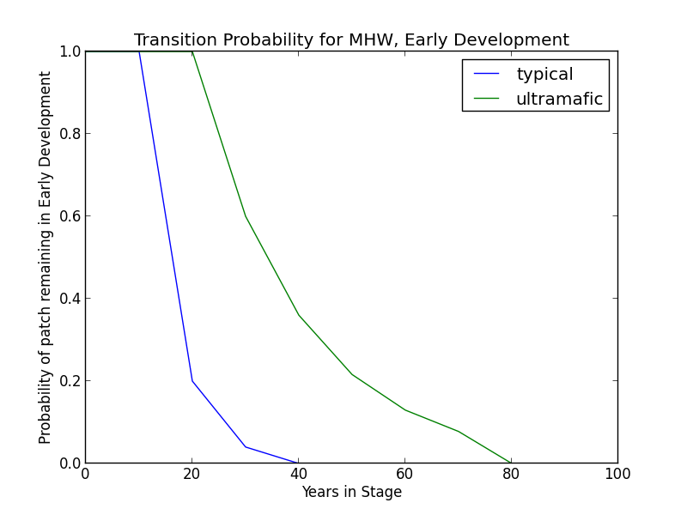**Ultramafic Modifier** Succession may be delayed. Thus, in the absence of disturbance, this class will begin transitioning to MD after 30 years and may be delayed in the ED condition for as long as 80 years. A stand in this condition succeeds at a rate of 0.4 per time step.

**Wildfire Transition** High mortality wildfire (100% of fires in this condition) recycles the patch through the ED condition. Low mortality wildfire is not modeled for this condition class.

**Mid Development (MD)**

**Description** Sparse ground cover of grasses, forbs, and shrubs; moderate to dense cover of trees, primarily hardwoods such as *Q. chrysolepis* and *Q. kelloggii*. Conifers such as *P. menziesii* are present at low densities in emergent status. The shrub understory is still a significant presence (LandFire 2007a). Ultramafic sites are characterized by open *Pinus ponderosa, Pinus sabiniana,* or *Pinus jeffreyi* stands with an understory comprised of grasses, forbs, and shrubs (LandFire 2007b).

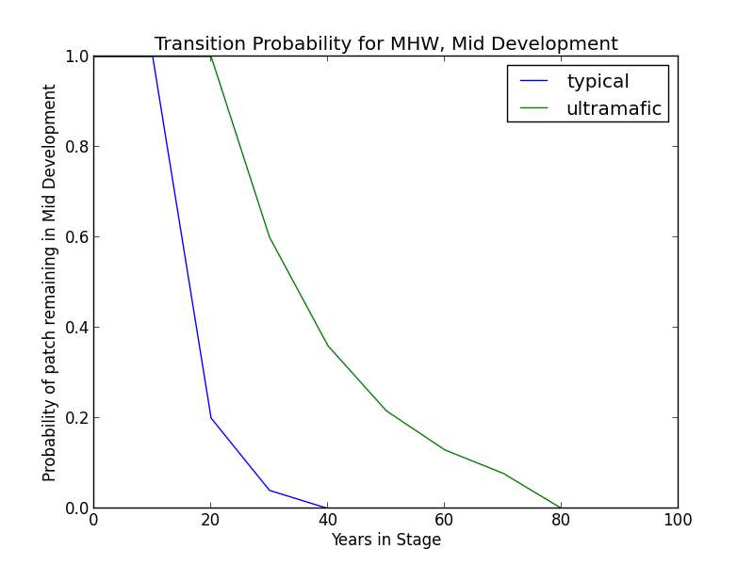**Succession Transition** After 20 years without a wildfire-triggered transition, this class will begin transitioning to late development. The rate of succession per time step is 0.8. At 40 years, all stands will have succeeded.

* **Ultramafic Modifier** Succession may be delayed. Thus, in the absence of disturbance, this class will begin transitioning to LD after 30 years and may be delayed in the MD condition for as long as 80 years. A stand in this condition succeeds at a rate of 0.4 per time step.

**Wildfire Transition** High mortality wildfire (2.5% of fires in this condition) recycles the patch through the ED condition. Low mortality wildfire (97.5%) does not effect a change in the MD condition.

* **Ultramafic Modifier** High mortality wildfire (7.0% of fires) recycles the patch through the ED condition. Low mortality wildfire (93.0%) does not effect a change in the MD condition.

**Late Development (LD)**

**Description** Overstory of large and very large trees, often with canopy cover over 60%. *P. menziesii, Q. chrysolepis,* and *Arctostaphylos mewukka* may occur. Conifers are taller and larger than in MD and clearly form the upper canopy layer here. Shrubs persist in openings but those in shade are likely to begin senescing (LandFire 2007a). On ultramafic sites, large *Pinus ponderosa, Pinus sabiniana,* or *Pinus jeffreyi* are the primary conifer species. Grass savannah persists on sites experiencing low intensity fire (with *Festuca, Achnatherum,* and *Danthonia*). Where fire is less frequent, chaparral shrubland develops (with *Arctostaphylos* and *Quercus breweri*) (LandFire 2007b).

**Succession Transition** In the absence of disturbance, this class will maintain, regardless of soil characteristics.

**Wildfire Transition** High mortality wildfire (2.4% of fires) recycles the patch through the ED condition. Low mortality wildfire (97.6%) does not effect a change in the MD condition.

* **Ultramafic Modifier** High mortality wildfire (6.7% of fires) recycles the patch through the ED condition. Low mortality wildfire (93.3%) does not effect a change in the MD condition.

**Condition Classification**

Table 2. Classification of cover condition for MHW. Diameter at Breast Height (DBH) and Cover From Above (CFA) values taken from EVeg polygons. DBH categories are: null, 0-0.9”, 1-4.9”, 5-9.9”, 10-19.9”, 20-29.9”, 30”+. CFA categories are not used for this condition because there is no “closed” vs. “open” differentiation. Each row in the table below should be read with a boolean AND across each column of a row.

|  |  |  |  |  |  |
| --- | --- | --- | --- | --- | --- |
| Cover Condition | Overstory Tree  Diameter 1 (DBH) | Overstory Tree  Diameter 2 (DBH) | Total Tree  CFA (%) | Conifer  CFA (%) | Hardwood  CFA (%) |
| Early All | 0-4.9” | any | any | any | any |
| Mid All | 5-19.9” | any | any | any | any |
| Late All | 20-40”+ | any | any | any | any |

**Draft Model**

(See PDF) Disturbance-Succession model for MHW.

**References**

Allen-Diaz, Barbara, Richard Standiford, and Randall D. Jackson. “Oak Woodlands and Forests.” In *Terrestrial Vegetation of California, 3rd Edition*, edited by Michael Barbour, Todd Keeler-Wolf, and Allan A. Schoenherr, 313-338. Berkeley and Los Angeles: University of California Press, 2007.

Barrett, S., D. Havlina, J. Jones, W. Hann, C. Frame, D. Hamilton, K. Schon, T. Demeo, L. Hutter, and J. Menakis. *Interagency Fire Regime Condition Class Guidebook*. Version 3.0. USDA Forest Service, US Department of the Interior, and The Nature Conservancy, 2010. <http://www.frcc.gov>. Accessed 5 June 2013.

“CalVeg Zone 1.” Vegetation Descriptions. *Vegetation Classification and Mapping*. 11 December 2008. U.S. Forest Service. <http://www.fs.usda.gov/Internet/FSE_DOCUMENTS/fsbdev3_046448.pdf>. Accessed 2 April 2013.

LandFire. “Biophysical Setting Models.” Biophysical Setting 0610430: Mediterranean California Mixed Evergreen Forest. 2007a. LANDFIRE Project, U.S. Department of Agriculture, Forest Service; U.S. Department of the Interior. <http://www.landfire.gov/national_veg_models_op2.php>. Accessed 9 November 2012.

LandFire. “Biophysical Setting Models.” Biophysical Setting 0711700: Klamath-Siskiyou Xeromorphic Serpentine Savanna and Chaparral. 2007b. LANDFIRE Project, U.S. Department of Agriculture, Forest Service; U.S. Department of the Interior. <http://www.landfire.gov/national_veg_models_op2.php>. Accessed 30 November 2012.

McDonald, Philip M. “Montane Hardwood (MHW).” *A Guide to Wildlife Habitats of California*, edited by Kenneth E. Mayer and William F. Laudenslayer. California Deparment of Fish and Game, 1988. <http://www.dfg.ca.gov/biogeodata/cwhr/pdfs/MHW.pdf>. Accessed 4 December 2012.

O’Geen, Anthony T., Randy A. Dahlgren, and Daniel Sanchez-Mata. “California Soils and Examples of Ultramafic Vegetation.” In *Terrestrial Vegetation of California, 3rd Edition*, edited by Michael Barbour, Todd Keeler-Wolf, and Allan A. Schoenherr, 71-106. Berkeley and Los Angeles: University of California Press, 2007.

Skinner, Carl N. and Chi-Ru Chang. “Fire Regimes, Past and Present.” *Sierra Nevada Ecosystem Project: Final report to Congress, vol. II, Assessments and scientific basis for management options*. Davis: University of California, Centers for Water and Wildland Resources, 1996.

Van de Water, Kip M. and Hugh D. Safford. “A Summary of Fire Frequency Estimates for California Vegetation Before Euro-American Settlement.” *Fire Ecology* 7.3 (2011): 26-57. doi: 10.4996/fireecology.0703026.